Supplementary Figure 1:

1a. Correlation between BPRS and TLR2 expression on monocytes 1b. Correlation between BPRS and TLR9 expression on B cells at baseline at baseline

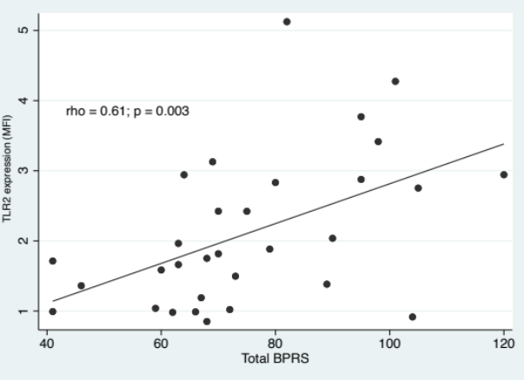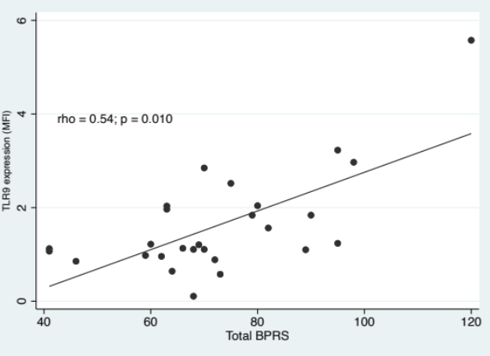

Total BPRS: total score obtained with BPRS scale Total BPRS: total score obtained with BPRS scale

MFI: mean ﬂuorescence intensity MFI: mean ﬂuorescence intensity

1c. Correlation between BPRS and TLR9 expression on monocytes at baseline

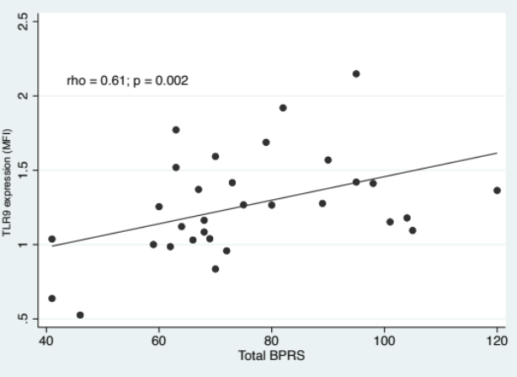

Total BPRS: total score obtained with BPRS scale

MFI: mean ﬂuorescence intensity

Supplementary Figure 2:

2a. Correlation between SAPS and IL-6 after TLR2 stimulation 2b. Correlation between BPRS and TNF-α after TLR3 stimulation on B cells at baseline on T cells at baseline

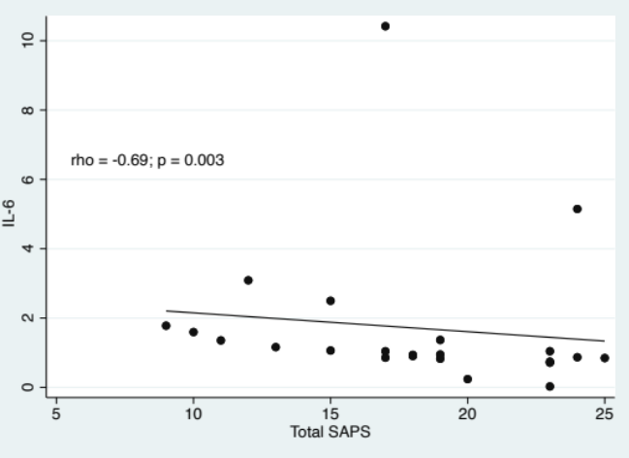 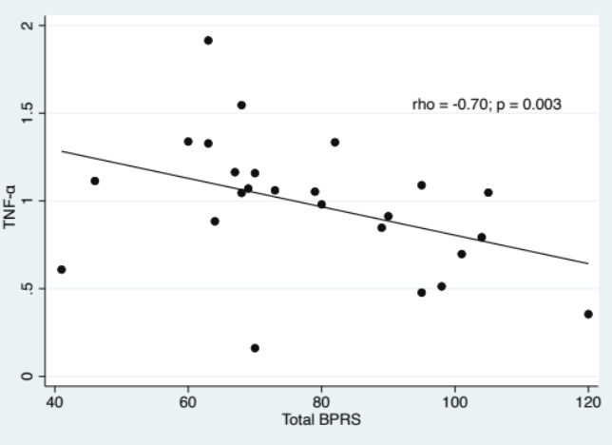 Total SAPS: total score obtained with SAPS scale Total BPRS: total score obtained with BPRS scale

2c. Correlation between BPRS and IL-1β after TLR9 stimulation 2d. Correlation between SAPS and IL-1β after TLR9 stimulation on monocytes at baseline on monocytes at baseline

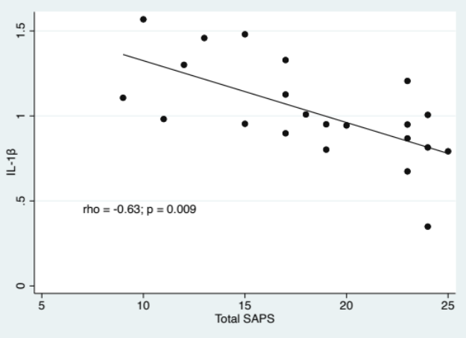 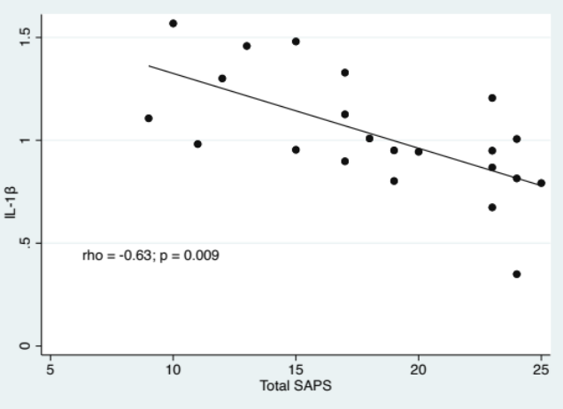Total BPRS: total score obtained with BPRS scale Total SAPS: total score obtained with SAPS scale

